The Pennsylvania Association of School Retirees (PASR) was founded in 1937 and is the largest group of its kind in Pennsylvania, and third largest school retiree organization in the nation. Strictly a volunteer membership organization, PASR consists of, is governed by, and works exclusively to promote the interests and serve the needs of ALL persons who retired from the public schools of Pennsylvania.

PASR's mission statement:

To serve others in need and help one another enjoy retirement.

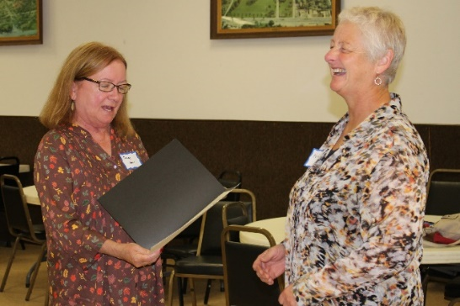

Clarion County PASR

Membership Application or Renewal

Name __________________________

Address ________________________

City/State _______________________

Zip _________ Phone* _____________

Email _____________________

District from which you retired ________________ Year retired ______

CCPASR Annual (July 1-June30) $20

CCPASR Life $100

State PASR Annual $60

State PASR 3 year $150

State PASR Life $700

Please mail this form with your check made payable to CCPASR to:

Paula Bowersox

16 Horizon Heights

Clarion, PA 16214

*This information will NOT be shared with 3rd parties.

Clarion County
Chapter of

PASR

PASR is an association comprised of members who are all retired employees of the public schools of Pennsylvania.

We are former teachers, administrators, counselors, nurses, secretaries, aides, bus drivers, cafeteria workers, maintenance staff —

anyone who is now receiving a pension from the Pennsylvania School Employees Retirement System (PSERS).

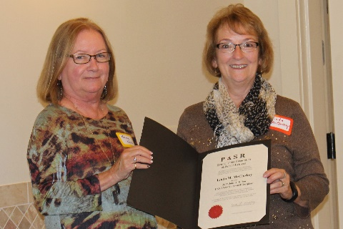

Pennsylvania Association

of School Retirees

www.pasr.org

www.ccpasr.com
PASR was established in 1937 and is a pioneer of nonprofit voluntary membership organizations nationally—having helped establish both the National Retired Teachers’ Association in 1947 and the nation’s largest senior organization, AARP, in 1958.
Currently, there are 73 local PASR chapters. Most are found throughout the state of Pennsylvania, which has been divided into twelve geographic regions within the state. In addition, a thirteenth region exists to service out-of-state members from Delaware, Florida, Maryland, New Jersey, and the Carolinas.
Local Service
Yearly Educational Enhancement Grants to local school districts.
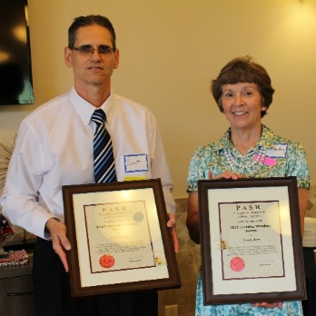
Yearly recognition of current
school employees.

Make new friends and enjoy monthly visits with

longtime friends.

Come whenever you are able.
Local RECREO
Monthly Luncheons

Active member

Any person

- retired under the Pennsylvania Public School Employees Retirement System

- retired from a Pennsylvania state-related educational institution

- retired under a Public-School Retirement System from another state

Associate Member

Any person

- who is interested in the work of the Chapter

- who is a retired former school employee who has retired from a non-public school

- who is an active school employee age 50 or more

- who is a spouse of an active member

Mark your calendar for the 3rd Thursday of each month.

